**PROGRAM-3**

**AIM**-Write a algorithm and program to sort n numbers using bubble sort technique.

**Program-**

#include <stdio.h>

int main()

{

int array[100], n, c, d, swap;

printf("Enter number of elements\n");

scanf("%d", &n);

printf("Enter %d integers\n", n);

for (c = 0; c < n; c++)

scanf("%d", &array[c]);

for (c = 0 ; c < n - 1; c++)

{

for (d = 0 ; d < n - c - 1; d++)

{

if (array[d] > array[d+1]) /* For decreasing order use < */

{

swap = array[d];

array[d] = array[d+1];

array[d+1] = swap;

}} }

printf("Sorted list in ascending order:\n");

for (c = 0; c < n; c++)

printf("%d\n", array[c]);

return 0;

}

**OUTPUT-**

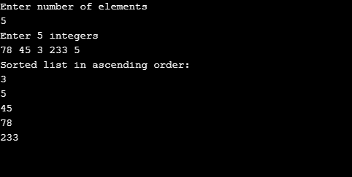

**Algorithm-**

procedure bubbleSort( list : array of items )

loop = list.count;

for i = 0 to loop-1 do:

swapped = false

for j = 0 to loop-1 do:

/* compare the adjacent elements */

if list[j] > list[j+1] then

/* swap them */

swap( list[j], list[j+1] )

swapped = true

end if

procedure bubbleSort( list : array of items )

loop = list.count;

for i = 0 to loop-1 do:

swapped = false

for j = 0 to loop-1 do:

/* compare the adjacent elements */

if list[j] > list[j+1] then

/* swap them */

swap( list[j], list[j+1] )

swapped = true

end if

**AIM**- Implement recursion in above question

**Program-**

#include<stdio.h>

void BubbleSortRecursion(int a[],int num);

int main()

{

int i,j,num,temp;

printf("Enter number of elements\n");

scanf("%d",&num);

int a[num];

printf("Enter numbers\n");

for(i=0;i<num;i++)

{

scanf("%d",&a[i]);

}

BubbleSortRecursion(a,num);

printf("Given numbers in Ascending order \n");

for(i=0;i<num;i++)

{

printf("%d\n",a[i]);

}

}

void BubbleSortRecursion(int a[],int num)

{

int i,j,temp;

i=num;

if(i>0)

{

for(j=0;j<num-1;j++)

{

if(a[j]>a[j+1])

{

temp=a[j];

a[j]=a[j+1];

a[j+1]=temp;

}

}

BubbleSortRecursion(a,num-1);

}

else

{

return;

}

}

**OUTPUT-**

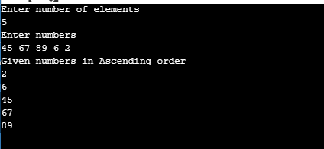

**Algorithm-**

//Recursive Bubble Sort

let recursiveBubbleSort = (arr, n = arr.length) => {

//If there is only single element

//the return the array

if(n == 1){

return arr;

}

//Swap the elements by comparing them

for(let j = 0; j < n - 1; j++){

if(arr[j] > arr[j + 1]){

[arr[j], arr[j+1]] = [arr[j+1], arr[j]];

}

}

//Recursively call the function to sort.

return recursiveBubbleSort(arr, n-1);

}